

**LECTURE NOTES**

**ON**

**ADVANCED CONSTRUCTION TECHNIQUES AND EQUIPMENT**

**Compiled by**

**Ms. NIKITA PATRO**

**Lecturer, Department of Civil Engineering**

**GANDHI ACADEMY OF TECHNOLOGY AND ENGINEERING**

**CONTENTS**

|  |  |  |
| --- | --- | --- |
| **S.N.** | **CHAPTERNAME** | **PAGENO.** |
| 1 | Advancedconstructionmaterials | 1-12 |
| 2 | Prefabrication | 14-25 |
| 3 | Buildingservices | 26-38 |
| 4 | Questionsandanswers | 39-48 |
| 5 | Construction equipment | 48-61 |

KIITPOLYTECHNIC

**LearningMaterials(Th.3)**

**ADVANCEDCONSTRUCTIONTECHNIQUES&EQUIPMENT**

**Semester-6th**

**KIITPolytechnic,Bhubaneswar**

**Chapter1:Advancedconstructionmaterials**

### PlasticasConstructionMaterial

Plastic is a general name given to a wide range of synthetic materials that are based on polymers. The constructionindustry usesplasticfora widerange ofapplicationsbecauseofitsversatility,strength-to- weight ratio, durability, corrosion resistance, and so on.

Plasticcanbemanufacturedintoformssuchas; pipes,cables,coverings,panels,films, sheetsandsoon; and can be formed or expanded to create low-density materials; and be dissolved in solvents.

Someoftheseplasticsmainusesintheconstructionindustryare,

* + Claddingpanels.
  + Cables
  + Pipesand gutters.
  + Windowsanddoors.
  + Shuttering
  + Walllinings
  + Floorcovering
  + Ceilingpanels.
  + Roof coverings.
  + Sinks,basins,baths,andshowers.

:Theadvantagesofusingplasticinconstructionarethatitislightweightyetstrongwhichmakesiteasier to transport and shift around sites. It is alsoresistant torot and corrosion and has strong weather ability due to it being capable of achieving tight seals.

: The disadvantages of plasticarethatit has ahighembodiedenergy content anda lowmodulus of elasticity, meaning that it is generally unsuitable for load-bearing applications.

## PROPERTIES: -

:Typically,constructionprofessionalsselectplasticmaterialsbasedonthefollowingcriteria:

1. Durability
2. Cost effectiveness
3. Recycling
4. Energysaving
5. Safety
6. Easyto install

UseofPlasticsinDifferentAspectsoftheConstructionIndustry 1.Flooring

Plasticmaterialslikepolyvinylchloride(PVC)andpolyethyleneareusedtomakeflooringless prone to wear and tear. It also decreases the sound pollution level and can be cleaned easily.

1. Roofing

To protect the outer surface of the roof from damage, two layers of differentplastic materialsarerequired.Theupperpartismadeofcoloredthermoplasticolefinorvinylwhile the lower part consists of polyurethane foamwhichconsumes less energy and keeps the interior of a house cooler.

1. Insulation

Polyurethane spray is frequently used for insulation when constructing green or low energy buildings. Rigid polyurethane foam is known for its high thermal resistance which promotes temperatureconsistency.Polyurethanefoamisalsopopularbecauseitislightweight,chemical resistant,andflameretardant.Duetoitsclosedcellnature,polyurethaneinsulationperformsas an air barrier, resulting in significant energy savings.

1. Wall

Astructuralinsulatedpanel(SIP) is a sandwich of expanded polystyrene amidst twoslim layersoforientedstrandboard.Thistypeofpre-fab,compositewallboardcan be transferredtotheworkplaceeasilyforaparticulartaskandprovidegoodsupportto columns and other associated essentials during renovation.

1. Pipes

Commonly made up of polyvinyl chloride (PVC), CPVC, acrylonitrilebutadienestyrene (ABS)orpolyethylene,plasticpipesareflexibleandverylightinweight,makingthemeasyto install.Alloftheseplasticmaterialsarealsohighlychemicalandwaterresistant,makingthem suitable for many extreme environments.

1. Windows

Polycarbonateisusedtomanufacturebuildingwindows.Thisplasticmaterialisstrong,clearand verylightinweight.Polycarbonatewindowsareconsideredmoreburglar-proofthanregularglass windows. Two plastics materials, vinyl and fiberglass, are used commonly in the production of windowframes.Fiberglassisextremelystrongwhilevinylisquitedurableandalsoinexpensive.

1. Doors

Some construction projects use doors made from a stiff polyurethane foam core with a fiber reinforced plastic (FRP) coating. The sandwich structure of these doors makes them incredibly strong.

## TYPES:-

**PVC**:-

Polyvinyl chloride (PVC), a synthetic resin made from the polymerization of vinyl chloride. Secondonlytopolyethylene amongtheplasticsinproductionandconsumption,PVCisusedin an enormous range of domestic and industrial products, from raincoats and shower curtains to window frames and indoor plumbing. A lightweight, rigid plastic in its pure form, it is also manufactured in a flexible “plasticized” form.

**RPVC**:-

RPVCmeansRigidPolyVinylChloridewhichcomesfromPVC.Polyvinylchloride(PVC), also known as vinyl, is a common plastic polymer (a polymer being a large molecule). It comes in two basic forms: flexible and rigid (RPVC). RPVC is used in construction (especially pipes), packaging etc. RPVC Pipes with high impact strength & load bearing capacity!

**HDPE**:-

High density polyethylene (HDPE) piping systems have been used for municipaland industrial water applications for over 50 years. Within Building & Construction Division, HDPEpipesareusedforgroundsourcegeothermalapplications,alsoknownasearthenergy or geoexchange systems.

**FRP**:-

Fibre-reinforced plastic(FRP)(also called fiber-reinforced polymer).FRP bars are usedas internal reinforcement for concrete structures. FRP bars, sheets, and strips are usedfor strengtheningofvariousstructuresconstructedfromconcrete,masonry,timber,andevensteel. Fibrereinforcedpolymersareusedintheconstructionofspecialstructuresrequiringelectrical neutrality.

**GRP**:-

GRPstandsfor'GlassReinforcedPlastic'amaterialmadefromapolyesterresin,whichisreinforcedbychoppedstrandmatglassfibrestoformaGRPlaminate.Itisaverypopular composite material to use because not only is it very strong but also surprisingly light.

### ColouredPlasticSheets:-

Plastic film is a thin continuous polymeric material. Thicker plastic material is often called a "sheet”.Plasticsheetsaregenerallylowcost,easytomanufacture,durable,strongfortheirweight, electrically and thermally insulative, and resistant to shock, corrosion, chemicals, and water.

1. **FIBERASACONSTRUCTIONMATERIAL**
   * Fiber or fibers is a class of material which are having continuous filaments or having discrete elongated pieces similar to the length of thread.
   * Fibersareveryimportantinthebiologyofplantsandanimalsforholdingtissuetogether. They are often used in the manufacture of other materials.
   * Fiberscanbespunintofilamentsorstringorropewhichcanbeusedasacomponentof composite material or matted into sheets so as to make the products like paper or felt.
   * Fibers are inorganic or organic, natural or synthetic. Synthetic fibers can be produced very cheaply and in large amounts as compared to natural fibers. Rayon and nylon are organic synthetic fibers.
   * Burlapis a coarse jute or hemp which is a natural fiber. Hessian is a jute fabric. Silk and cotton are produced from natural fibers.
   * Glasswool,leadwoolandasbestosaremineralfibersofwhichglasswoolandleadwool are synthetic fibers.
   * Steel fiber, carbon fiber and glass fiber are the new and recent trends used in the construction work.

# GeneralUsesof Fibers

* + Fibersareusedforpacking andmakingfabricsand felts.
  + Glasswoolmadeofveryfinefibersofglassisusedformakingacid-proofandfire-proof fabrics.
  + Glass wool is also used as a packing material for heat, sound and electric insulation. It is commonly used in a solar water system.
  + Lead wool prepared from finefibersoflead is used in water pipejoints to stop leakage of water. Natural jute fibers are extensively used in plumbing work to stop leakage of water.

# TypesofFibers:

Therearemainly threetypesoffiberswhicharecommonly usedas a[construction materials.](https://www.designingbuildings.co.uk/wiki/Construction_materials)

# Steelfiber

Steelfiberaremadefromthecolddrawnsteelwirewithlowcontentofcarbonorstainless steel

wire.Theyaremanufacturedinvarioustypessuchashookedsteelfibers,undulatedor

flatsteelfibersaccordingtotheneedrequiredintheconstructionproject.Thesefibersare usedintheconstructionforconcretereinforcement.Steelfiberreinforcedconcreteisless expensive than hand tied re-bar shape, dimensions and length of the fiber are more important because it increases the tensile strength of the concrete.

Steel fibers can only be used on surfaces so as to avoid corrosion and rust stains. Fiber- reinforced normal concrete is mostly used for on-ground floors and pavements and also used for the construction parts such as beams, pillars, foundation etc.

# PropertiesofSteel Fibers

* + Itincreasesthetensilestrengthof concrete.
  + Itismoretoughand hard.
  + Itavoidscorrosionandruststains.
  + Theyaremoreelasticin nature.
  + SteelfibersareavailablewithstandardsasASTM 820/96,ASTMC 1116/95andDIN 1045.
  + Ithas atensilestrengthof1.100N/mm².
  + Theyareavailableinthe shapeslikeflat,hookedandundulated.

# ApplicationsofSteel FibersonField

* + Steelfibersarehighlyusedintunnelliningwork.
  + Itismostlyusedintheconstructionofairportrunwaysandhighwaypavements.
  + Mostcommonly usedinprecastconcretesoastoincreasethetensilestrength.
  + Theyareusedin shotcrete.
  + Usedintheconstructionof parking.
  + Itisusedinanti-seismicbuildings.

# Carbonfibers

Carbonfiberisamaterial consistingofextremelythinfibersabout0.005mmto0.010mm in diameter and mostly composed of carbon atoms. Carbon fiber is alternately called graphite fiber. The carbon atoms are bonded together in microscopic crystals which are moreorlessalignedparalleltothelongaxisofthefiber.Thecrystal alignmentmakessize of fiber more strong. Number of carbon fibers are twisted together so as to form a Yarn whichcanbeusedasitexistorwovenintoafabric.It can be combined with a plastic resin and wound or moulded to form composite materials like carbon fiber reinforced plastic to provide a high strength to weight ratio of the materials. The atomic structure of carbon fiber is similar to that of graphite consisting of sheets of carbon atoms arranged in a regular hexagonal pattern. Carbon fibers shows the numberof properties very close to the properties ofasbestos. Each carbon filament thread

isabundleofmanythousandcarbonfilaments.Asinglesuchfilamentisathintubewitha diameter of 5-8 μm (i.e. 5-8 micrometres) and consists of almost exclusively of carbon.

# PropertiesofCarbonFibers

* + Ithasahigh tensilestrength,lowweight andlowthermalexpansion.
  + Theyarerigidmaterialswhichareresistanttostretchingandcompression.
  + Itischemicallyinertorunreactivematerials.
  + Theyareresistantto corrosion.
  + Fiberscontainedabout85%carbonhasexcellentflexuralstrength.

# ApplicationofCarbonFibers

* + Carbonfiberismostlyusedtoreinforcecomposite material.
  + Reinforced Carbon-Carbon (RCC) consists of carbon fiber-reinforced graphite and is used structurally in high temperature applications.
  + Itincreasesthetensileaswellascompressivestrength ofconcrete.
  + Duetohightensilestrength,lowweightandlowthermalexpansionitmakesthecarbon fiber very popular in aerospace, military and motorsports along with other competition sports.
  + Carbonfiberisextensivelyusedinthebicycleindustry,especiallyforhigh-performance racing bikes.
  + Itisalsousedinsometennis rackets.
  + It is now being used in musical instruments for its weather resilience and ability to recreate the tone of guitars.

# Glass fibers

Itisalso calledas fiberglass.Glassfiberisthematerialmadefromextremelyfinefibers ofglass.Itwas inventedin1938byRussellGamesSlayter.In 1893,EdwardDrummond Libbey exhibited a dressat the World’s Calumbian Expositionincorporating glass fibers with the diameter and texture of silk fibers. This was first worn by the well known and popularstageactressofthetimeGeorgiaCayvan.Therearetwomaintypes ofglassfiber manufacture and two main types of glass fiber product. First fiber is made either from a direct melt process or a marble remelt process. Both start with the raw materials in solid form.Itisalmostandalwaysmodeofplatinumalloyedwithrhodiumforbetterdurability. Platinumisusedbecausetheglassmelthasanaturalaffinityforwettingit.Thefreshand thin fibers are more strong because the thinner fibers are more ductile.

# PropertiesofGlassFibers

* + Ithashighratioofsurfaceareatoweight.
  + Theyhavegoodthermalinsulation.
  + Ithasagoodtensilestrengthbuthasnostrengthagainst compression.
  + Compressivestrengthisweakbutcanbeincreasedbyreinforcing itwithplastic.
  + Whentheglassfiberisreinforcedwithplastic,thenreinforcedmaterialcanresistsboth compressive and tensile forces as well.
  + Itisresistanttochemical attack.However,ifitssurfaceareaisincreased,thenitmakes them more susceptible to chemical attack.
  + Theyarecorrosionresistant.

# ApplicationofGlass Fibers

* + Corrugated fiber glass panels are widely used for outdoor canopy or greenhouse construction.
  + It is used as a reinforcing agent for many polymer products like FRP and GRP which uses tubs, pipes for drinking water and ‘sewers, office plant containers and flat roof systems etc.
  + Itisreinforcedwithplasticmaterialsoastoincreasetensilestrength.
  + Uses of regular fiber glass are mats, insulation, reinforcement sound absorption, heat resistance fabrics, corrosion resistant fabrics and high strength fabrics.
  + Glass fiber reinforced plastics are used in the house building market for the production ofroofinglaminate,doorsurrounds,over-doorcanopies,windowcanopiesanddormers, chimneys, coping system, heads with keystone and sill etc.
  + The reinforced glass fiber with polymer and plastic is commonly used in fire water systems, cooling water systems, drinking water systems, sewage systems, waste water systems, gas system etc.

## ARTIFICIALTIMBER

Reduction of moisture content along with improving some qualities before the use ofwoods is called seasoning of timber. By seasoning, generally, the moisture is reduced to about 15% where new cut woods bear about 50%.

### ReasonsforSeasoning

Seasoningoftimberisdonetofulfillsomespecificrequirement.Followingsarethe reasons to perform timber seasoning.

* 1. Tochangeandimprovethepropertiesof wood.
  2. Tomakeacorrectpercentageofshrinkingof woods.
  3. Tomakeaconfidentuseofwoods.
  4. Toreducetheadversebehaviourofwoods.

### MethodsofSeasoningofTimber

Therearemainlytwomethodsofseasoningoftimber.These are:

1. NaturalSeasoning
2. ArtificialSeasoning

Followingtreediagramcanbeusedtoillustrateallthemethodsoftimberseasoning.

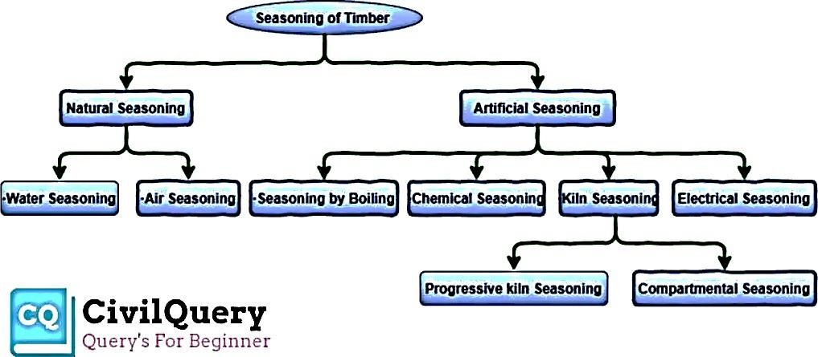

### NaturalSeasoning

Seasoningof woodsortimbersusingnatural elementsiscallednaturalseasoning.eg. waterand air seasoning.

### Water seasoning

Removal of wood sap immersing logs into water flowis called water seasoning. It is carried out on the banks of the river while thicker ends are kept towards upstream. After that, the logs are allowed to dry. Disadvantage: It is time consuming such as 2 to 4 weeks generally.

### Airseasoning

Exposingthewoodstoairforseasoning.Atfirst,aplatformisrequiredthatisbuilton theground at 300mm height above the ground.

Secondly,thearrangementofwoodsinlayers.Aircirculationismaintainedbetweenlogsbecause ithelpstoreducethemoisture whichisimportant forseasoning. Theenvironmentforthisneedto maintainsomeconditions.Aclean,shady,dry,coolplace ispreferred.Sometimeslogsarecoated bytheimpermeablesubstancetoreduceextreme moisture.Toimprovethequalityoilcoating,

thick paint coating is maintained. To prevent fungal infection logs are treated with petrol or gasoline.

### Advantage:

* + Goodqualityofseasoned wood.
  + Alargeamountisconvenientinthisprocess.
  + Well-seasonedtimberisformed.

### Disadvantage:

* + It’saslowprocess.

### ArtificialSeasoning

1. **Seasoningby Boiling**

Seasoningbyboilingwoodlogsinhotwateriscalledseasoningbyboiling.Dryingisdoneafter proper boiling. For a large amount of wood, it is done in an enclosed place where hot steam is passed.

### Advantages

* + Ittakesashortamountoftime.Generally,3-4hoursisgoodenough.Developsthestrengthand elasticity.

### Disadvantages

* + It is serviceable basically for a small quantity of wood, not convenient for a large amount. The cost is high.

### Chemicalseasoning

Reduction of moisture using salt solution is called chemical seasoning. After the absorption of water by the solution logs are let to dry.

### Advantage

* + Itincreasesthestrengthofthetimber.
  + Itislesstime-consuming.

### Disadvantage

* + Chemicalreagentscansometimesreducestrength.
  + It can cause a problem in gluing or finishing or corrosionwhile using.

### Kilnseasoning

Seasoningofwoodbyusingalargechamberor ovenwherethereisagoodprocessforthe circulation of hot air.

### Advantage

Mosteffectiveandeconomicseasoning.

Kilnseasoningcanbedoneby2processessuchas:-

* + Progressive kiln Seasoning: Wood log is entered through the kiln ant the temperature andhumiditydifferentialsaremaintainedthroughthelengthofthekilntomaintainproperdrying.
  + CompartmentalSeasoning:It’smaintainedbyenclosedcontainerorbuildings. Advantage: It accelerates the process because external energy is used.

### Electricalseasoning

Dry wood is non-conductor of electricity while green timber is a conductor, so, can pass alternating current. Thus, in this method alternating current is used for the resistance of timber againstelectricityismeasuredateveryintervaloftime.Whentherequiredresistanceisreached seasoning, process is stopped because resistance of timber increases by reducing moisture content in it. It is also called as rapid seasoning and it is uneconomical.

### MiscellaneousMaterials.

A category of asbestos-containing building material comprised mostly of nonfriable asbestos products and materials, such as ceiling tiles, floor tiles, roofing felt, transit pipes and panels, exterior siding, fabrics, and sheetrock systems.

### AcousticsMaterial

Whenthesoundintensityismore,thenit givesthegreat troubleornuisancetotheparticular area like auditorium, cinema hall, studio, recreation centre, entertainment hall, college reading hall. Henceitisveryimportanttomakethatareaorroomtobesoundproofbyusingasuitablematerial called as ‘Acoustic material’. It is measured in decibels (db).

### PropertiesofAcousticMaterial

* Soundenergyiscapturedand adsorbed.
* Ithasalowreflectionandhighabsorptionofsound.
* Higherdensityimprovesthesoundabsorptionefficiencyatlowerfrequencies.
* Higherdensitymaterialhelptomaintainalowflammabilityperformance.Henceacoustic material should have higher density.
* It controlsthesoundandnoiselevelsfrommachineryandothersourcesforenvironmental amelioration and regulatory compliance.
* Acousticmaterialreducestheenergyofsoundwavesastheypassthrough.
* Itsuppressesechoes,reverberation,resonanceandreflection.

### UsesofAcousticMaterial

* Acoustic materials can be used for noise reduction and noise absorption. Itmakesthesoundmoreaudiblewhichiscleartolistenwithoutanydisturbances.

2.Itsuppressesechoes,reverberation,reflectionandresonance.

* Importantspecificationsfornoisereductionandnoiseabsorptionproductsinclude noise attenuation and noise reduction coefficient.
* 4.Avinylacousticbarrierblockscontrolsairbornenoise(streettraffic,voices,music)from passing through a wall ceiling or floor.
* 5.Acousticfoamandacousticceilingtilesabsorbsoundsoastominimizeecho and reverberation within a room.
* 6.Soundproofdoorsandwindowsaredesignedtoreducethetransmissionofsound.
* Asoundproofwall(treatedbyaaccuratematerial)canincorporatesoundproofing andacoustic materials to meet desired sound transmission class (STC) values.

### Wallcladding

Wall cladding is a type of decorative covering intended to make a wall look like it is made of a differentsortofmaterialthanitactuallyis.Someofthemostcommonexamplesareontheoutside of buildings, but cladding can also be an artistic element in interior decorating.

ThemostcommontypesofcladdingareStoneCladding,BrickCladding,TimberCladding,Metal Cladding, Concrete Cladding, Glass Cladding.

### Plasterboard

Plasterboardisa panelmade ofcalciumsulphatedihydrate (gypsum) usually pressed betweena facer and a backer. It is used to make interior walls and ceilings. This 'Drywall’ construction became popular as a quicker alternative to traditional lath application.

### Microsilica

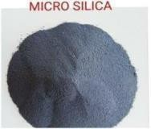

Microsilicaorsilicafumeis anexcellentadmixtureforconcreteasitleadsto better engineering properties. It reduces thermal cracking, improves durability, and increases strength. Silica fume concrete has a number of construction applications.

### ArtificialSand

Artificial sand, also called crushed sand or mechanical sand, refers to rocks, mine tailings or industrial waste granules with a particle size of less than 4.75 mm, which are processed by mechanical crushing and sieving, but does not include soft and weathered granules.

### BondingAgents

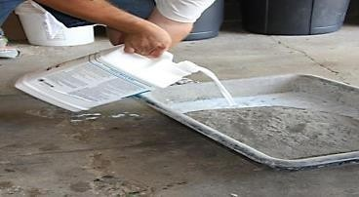

Bonding agents are natural, compounded or synthetic materials used to enhance the joining of individual members of a structure without employing mechanical fasteners. The most commonly usedtypesofbondingagentsaregenerallymadefromnaturalrubber,syntheticrubberorfromany

other organic polymers. The polymers include polyvinyl chloride, polyvinyl acetate etc. With the addition of bonding agent in repair mortar or concrete, the reduced water-cement ratio can be adopted for the same workability, thereby reducing drying shrinkage.

### Adhesive



Construction adhesive is a general-purpose adhesive used for attaching drywall, tile, moulding, and fixtures to walls, ceilings, and floors. It is most commonly available in tubes intended for use.

## MODULE-2 PREFABRICATION

Prefabrication is the practice of assembling components of a structure in a factory or other manufacturing site, and transporting complete assemblies or sub-assemblies to the construction site where the structure is to be located. The term is used to distinguish this process from the more conventionalconstructionpracticeoftransportingthebasicmaterialstotheconstructionsitewhereall assembly is carried out.

Thetermprefabricationalsoappliestothemanufacturingofthingsotherthanstructuresatafixedsite. Itisfrequentlyusedwhenfabricationofasectionofamachineoranymovablestructureisshiftedfrom themainmanufacturingsitetoanotherlocation,andthesectionissuppliedassembledandreadytofit. Itisnotgenerallyusedtorefertoelectricalorelectroniccomponentsofamachine,ormechanicalparts such as pumps, gearboxes and compressors which are usually supplied as separate items, but to sections of the body of the machine which in the past were fabricated with the whole machine. Prefabricatedpartsofthebodyofthemachinemaybecalled'sub-assemblies'todistinguishthemfrom the other components.

### History

Prefabrication has been used since ancient times. For example, it is claimed that the world's oldest known engineered roadway, the Sweet Track constructed in England around 3800 BC, employed prefabricated timber sections brought to the site rather thanassembled on-site.[citation needed]

Sinhalese kings of ancient Sri Lanka have used prefabricated buildings technology to erect giant structures, which dates back as far as 2000 years, where some sections were prepared separately and then fitted together, specially in the Kingdom of Anuradhapuraand Kingdom of Polonnaruwa.

After the great Lisbon earthquake of 1755, the Portuguese capital, especially the Baixa district, was rebuilt by using prefabrication on an unprecedented scale. Under the guidance of Sebastião José de Carvalho e Melo, popularly known as the Marquis de Pombal, the most powerful royal minister of D. Jose I, a new Pombaline style of architecture and urban planning arose, which introduced early anti-seismic design features and innovative prefabricated construction methods, according to which large multistory buildings were entirely manufactured outside the city, transported in pieces and then assembled on site. The process, which lasted into the nineteenth century,lodged the city's residents in safe new structures unheard-of before the quake.

Also in Portugal, the town of Vila Real de Santo António in the Algarve, founded on 30 December 1773, was quickly erected through the use of prefabricated materials en masse. The first of the prefabricated stones was laid in March 1774. By 13 May 1776, the centre of the town had been finished and was officially opened.

In 19th century Australia a large number of prefabricated houses were imported from the United Kingdom.

The method was widely used in the construction of prefabricated housing in the 20th century, such as in the United Kingdom as temporary housing for thousands of urban families "bombed out" during World War II. Assembling sections in factories saved time on-site and the lightness of the panels reducedthecostoffoundationsandassemblyonsite.Colouredconcretegreyandwithflatroofs,prefab houses were uninsulated and cold and life in a prefab acquired a certain stigma, but some London prefabs were occupiedfor much longer than the projected 10 years.[1]

The Crystal Palace, erected in London in 1851, was a highly visible example of iron and glass prefabricated construction; it was followed on a smaller scale by Oxford Rewley Road railway station.

### Currentuses

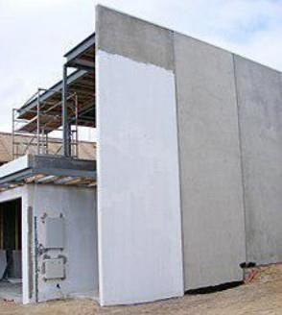

Ahousebeingbuiltwithprefabricatedconcretepanels.

The most widely used form of prefabrication in building and civil engineering is the useof prefabricated concrete and prefabricated steel sections in structures where a particular part or form is repeated many times. It can be difficult to construct the formwork required to mould concrete components on site, and delivering wet concrete to the site before it starts to set requires precise time management. Pouring concrete sections in a factory brings the advantages of being able to re-use mouldsandtheconcretecanbemixedonthespotwithouthavingtobetransportedtoandpumpedwet onacongestedconstructionsite.Prefabricatingsteelsectionsreduceson-sitecuttingandweldingcosts as well as the associated hazards.

Prefabrication techniques are used in the construction of apartment blocks,andhousing developments withrepeated housing units. The quality of prefabricated housing units had increased to the point that they may not be distinguishable from traditionally built units to those thatlive in them. The technique is also used in office blocks, warehouses and factory buildings. Prefabricated steel and glass sections are widely used for theexterior of large buildings.

Detachedhouses,cottages,logcabin,saunas,etc.arealsosoldwithprefabricatedelements. Prefabricationofmodularwallelementsallowsbuildingofcomplexthermalinsulation,windowframe components,etc.onanassemblyline,whichtendstoimprovequalityoveron-siteconstructionofeach individualwallorframe.Woodconstructioninparticularbenefitsfromtheimprovedquality.However, traditionoftenfavorsbuildingbyhandinmanycountries,andtheimageofprefabasa"cheap"method only slows its adoption. However, current practice already allows the modifying the floor plan accordingtothecustomer'srequirementsandselectingthesurfacingmaterial,e.g.

apersonalizedbrickfacadecanbemasonedeveniftheload-supportingelementsaretimber.

TransportationofprefabricatedAirbuswingassembly

Prefabrication saves engineering time on the construction site in civilengineering projects.Thiscanbevitaltothesuccessofprojectssuchasbridgesandavalanchegalleries, where weather conditions may only allow brief periods of construction. Prefabricated bridge elements and systems offer bridge designers andcontractors

significantadvantagesintermsofconstructiontime,safety,environmentalimpact,constructibility,and cost. Prefabrication can also help minimize the impact on traffic from bridge building. Additionally, small, commonly used structures such as concrete pylons are in most cases prefabricated.

Radio towers for mobile phone and other services often consist of multiple prefabricated sections. Modern lattice towers and guyed masts are also commonly assembled ofprefabricated elements.

Prefabricationhasbecomewidelyusedintheassemblyofaircraftandspacecraft,withcomponents such as wings and fuselagesections oftenbeingmanufacturedin different countries orstates from the final assembly site. However, this is sometimes for political rather than commercial reasons, such as for Airbus.

### Processandtheory

Anexamplefromhouse-buildingillustratestheprocessofprefabrication.Theconventionalmethodof building a house is to transport bricks, timber, cement, sand, steel and construction aggregate, etc. to thesite,andtoconstructthehouseonsitefromthesematerials.Inprefabricatedconstruction,onlythe foundations are constructed in this way, while sections of walls, floors and roof are prefabricated (assembled) in a factory (possibly with window and door frames included), transported to the site, liftedinto place by a crane and bolted together.

Prefabricationisusedinthemanufactureofships,aircraftandallkindsofvehiclesandmachines where sections previously assembled at the final point of manufacture are assembled elsewhere instead, before being delivered for final assembly.

Thetheorybehindthemethodisthattimeandcostissavedifsimilarconstructiontaskscanbegrouped, and assembly line techniques can be employed in prefabrication at a location where skilled labour is available,whilecongestionattheassemblysite,whichwastestime,canbereduced.Themethodfinds applicationparticularlywherethestructureiscomposedofrepeatingunitsorforms,orwheremultiple copiesofthesamebasicstructurearebeingconstructed.Prefabricationavoidstheneedtotransportso manyskilledworkerstotheconstructionsite,andotherrestrictingconditionssuchasalackofpower, lack of water, exposure to harsh weather or a hazardous environmentare avoided. Against these advantages must be weighed the cost of transporting prefabricated sectionsand lifting them into positionastheywillusuallybelarger,more fragileandmoredifficulttohandlethanthematerialsand components of which they are made.

### Typesofprefabricatedsystems

There are two main types of prefabrication, namely volumetric (often referred to as 'modular') and panellised.Bothofthesetypesofconstructioncanbeachievedintimber,steelandconcrete,andcan also be mixed within the same scheme.

Steel systems for housing are usually light gauge galvanised steel. Timber systems can be relatively traditionalinthattheconstructionmirrorswhatmightbeproducedonsiteusingcomponentssuchas timberstudsandsheathing.ItcanmakeuseoftimberIbeamswhichgivelongerspanswitharelatively lightweightbeam.AthirdoptionisStructuralInsulatedPanelsystems,whichusefewerstudsandrely in part on the bond between rigid insulation core and outer sheathing materials for strength.

Onefactorthatdifferentiates allprefabricatedtimbersystemsfromwhatmightbetermed traditional timber frame is the amount of work undertaken in the factory.

While there does not appear to be a formal definition separating the two, the prefabricated panelmightincludeanyinsulationmaterial,thesheathingboardsandpossiblysomeservices.

### Classificationofprefabrication

**Classificationofprefabricatedconstructionsystem**

SmallerdegreePrefabrication:Heretheprefabricationisdoneinthesmallerscale.precast brick

Medium degreePrefabrication:Here theprefabricationisdone in the moderate scale.Large degree Prefabrication : Here the prefabrication is done in the large scale.

### Advantages

1. Movingpartialassembliesfromafactoryoftencostslessthanmovingpre production resources to each site
2. Deployingresourceson-sitecanaddcosts;prefabricatingassembliescansavecosts byreducing on-site work
3. Factorytools-jigs,cranes,conveyors,etc.-canmakeproductionfasterandmoreprecise
4. Factorytools-shaketables,hydraulictesters,etc.-canofferaddedqualityassurance
5. Consistentindoorenvironmentsoffactorieseliminatemostimpactsofweatheronproduction
6. Cranesandreusablefactorysupportscanallowshapesandsequenceswithout expensive on-site falsework
7. Higher-precisionfactorytoolscanaidmorecontrolledmovementofbuildingheat andair,for lower energy consumption and healthier buildings
8. Factory production can facilitate more optimal materials usage, recycling, noise capture, dust capture, etc.
9. Machine-mediated parts movement,andfreedom from windandraincanimproveconstruction safety

### Disadvantages

* 1. Transportation costs may be higher for voluminous prefabricated sections than for their constituent materials, which can often be packed more densely.
  2. Large prefabricated sections may require heavy-duty cranes and precisionmeasurement and handling to place in position.

### DesignPrincipalofPrefabrication:

TheMainreasonstochoosePrecastConstructionmethodoverconventionalinmethod.1.Economy in large scale project with high degree of repetitioninwork construction. 2. Special requirement in finishing.

* 1. Consistencyinstructuralqualitycontrol.
  2. Fastspeedofconstruction.
  3. Constraintsinavailabilityofsiteresources(e.g.materials&Laborites)6. Other space & environmental constraints.

7. Overall assessment of some or all of the above factors which points to the superiority ofadopting precast construction over convention method.

The following details gives. The cost implications of precast construction & conventional in situ method.

8. Large groups of buildings from the same type of prefabricated elements tend to v look drab and monotonous.

1.LocalJobsarelast.

vThemainreasonstochoose.PrecastConstructionmethodoverconventionalinsitumethod.

1.Economy in largescale project withhighdegreeofrepetitionin workexecution. 2. Special architectural requirement in finishing.

1. Colysistonayinstructuralqualitycontrol.
2. Fastspeedofconstruction.
3. Constraints in availability of site resources ce.g.materials & labour etc.. 6. Other space & environmental constraints.

7.Overallassessmentofsomeoralloftheabovefactorswhichpointstothesuperiorityofadopting precast construction over conventional method

Thefollowingdetailsgivesthecostimplicationsofprecastconstruction&conventionalinsitu method.

### PrefabricationElements:

1. Flooring/Roofingsystem.
2. PriciestBeams
3. PrecastColumns
4. Precastwalkpanels.
5. recastStabs.

### Classification:

ThePrefabricationisclassifiedasfollowfromtheviewofdegreeofPrecastconstruction.

1. Smallprefabrication
2. MediumPrefabrication
3. LargePrefabrication
4. CastinSitePrefabrication
5. Off-Site(or)factoryPrefabrication
6. Opensystemofprefabrication
7. Closedsystemofprefabrication
8. Partialprefabrication
9. Totalprefabrication

### SmallPrefabrication :

Thefirst3typesaremainlyclassifiedaccordingtotheirdegreeofprecast

Elements using inthatconstructionforeg.:brickisasmallunitprecastandusedinbuilding.

Thisiscalledassmallprefabrication.Thatthedegreeofprecastelementisverypositio**Medium Prefabrication :**

Supposetheroofingsystemsandhorizontalmembersareprovidedwithpretestedelementsthose constructionareknownasmedium prefabricatedconstructionherethdegreeof precastelements are moderate.

### LargePrefabrication :

In large prefabrication most of the members like wall panels, roofing / flooring Systems, beams and columns are prefabricated. Here degree of precast elements are high.

### Cast-in-siteprefabrication:OFF-site(factory)prefabrication:

Oneofthemainfactor whichaffectthefactoryprefabricationistransport.Thewidthofmadwalls, mode of transport, vehicles are the factors which prefabrication is to be doneon site on factory.

Supposethefactorysituatedatalongdistancefromtheconstructionsiteandthevehiclehavetocross acongestedtrafficwithheavyweighedelementsthecostinsideprefabricationispreferredeventhough the same condition are the cast in siteprefabrication is preferred only when number of houses

andmoreforsmallelementstheconveyanceiseasierwithnormaltypeoflorryandtrailers.Therefore we can adoptfactory (or) OFF site prefabrication for this type of construction.

### Opensystemofprefabrication:

Inthetotalprefabricationsystems,thespaceframersarecastedasasingleunitanderectedat thesite.Thewallfittingandotherfixingaredoneonsite.Thistypeofconstructionisknown as open system of prefabrication.

### Closedsystemofprefabrication:

In this system the whole things are casted with fixingsand erected on their position. **Partial prefabrication :**

Inthismethodofconstructionthebuildingelement(mostlyhorizontal)requiredareprecastandthen erected. Since the costing of horizontal elements (roof / floor) often take there time due to erection of from work the completion of the building is delayed and hence this method is restored. In most of the building sites this method is popular more. Son in industrial buildings where the elements have longer spans. Use of double tees, channel units, cored stabs, slabs, hyperboloid shalletc., are some of the horizontalelements.

This method is efficient when the elements are readily available when the building reached the roof level. The delay caused due to erection of formwork, delay due to removal eliminated completely in thismethodof construction Suitable forany type of building provided lifting and erection equipments are available.

### TotalPrefabrication:

Very high speed can be achieved by using this method of construction. The method can be employed for frame type of construction or for panel type of or the total prefabrication canbe on site or off-site. The choice of these two methods depend on the situations when the factory produced elements are transported and erected site we call if off-site prefabrication. If this method is to be adopted then we have a very good transportation of the products to site. If the elements are cast near the building site and erected, the transportation of elements can be eliminated, but we have consider the space availabilityforestablishsuchfacilitiesthoughitistemporary.Thechoiceofthemethodofconstruction also depends on the following;

1. Typeofequipmentavailableforerectionandtransport.
2. Typeofstructuralscheme(linearelementsorpanel)
3. Typeofconnectionsbetweenelements.
4. Specialequipmentdevisedforspecialmethodconstruction

### Modularcoordination

Modular coordination is a concept for coordinating dimensions and space for which building, components are positioned. Basic unit of MC is module 1M which is equal to 100mm. MC is internationally accepted bythe International Standard of Organization (ISO). The introduction of MC in building facilitate proper planning, design construction and assembly of building components. The principleobjectiveofimplementationofMCistoimproveproductivity,moreflexibilityindesignand construction activities.

### Modularco-ordinationGrid:

**StructuralGrid:**

Itisusedtolocatethestructuralcomponentssuchasbeamandcolumns.

### PlanningGrid:

Itisusedforlocatingthespaceforbuildingcomponentslikerooms.

### ControllingGrid:

It is used for locating internal walls. Modular coordinated grid is used for locating the building components and the grids can be available in both horizontal and vertical planes. The grids are generated by measurement in modules.

### DimensionalGrid:

Modular coordinated grid network defines the space available for placing the components. An important factor is that the component must always undersized to grid size for providing space for jointspace.Manufacturedlengthofunitnominallength11½inchgridsizewouldbe12inchbecause of units were designed to be placed with ½ inch joints.

Inmodularcoordinationsystem,inplaceofgeometricserious,adifferentsystemofpreferred dimensions is used. For larger dimensions it is represented in modules like 1M=0.1m, for smaller dimensions sub modular increments 50mm or 25mm are used.

### Modularcoordinationsystemprovides,

1. Definingcoordinatingspacesforbuildingelementsandcomponents.
2. Rulesformaintainingthecomponentsizewhilemanufacturing
3. Rulesforselectingthecomponentsizeandprovidingtherequiredgridsizeinbuilding.
4. TheMCsystemallowsstandardizationindesignofbuildingcomponents, itencourages manufacturers and assemblers to enter in open market.
5. ItisdifficulttomanufacturethecomponentinSIunitmmtolerance.Butitiseasierfor manufacturer to make in module tolerance system.

### AdvantagesofModularCoordination:

1. Facilitate cooperation between building designer, manufacturer, traders,contractors.
2. Improvesfreedomindesignandpermitsflexibility.
3. Encouragesthepossibilityofinterchangingthecomponents.
4. Simplifiespositioningandplacingofcomponents
5. Ensures dimensional coordination between component with the rest of the building. 6. It is possible to get maximum economy in the production of components. 7. Reduces the need for making special sizes.

8. Increases the number of choices of components because of interchangeability. 9. Improves quality and productivity of construction.

1. Wastageinproductionandtimetakenforinstallationofcomponentsisreduced.
2. Ithelpstoachievetheresponsibilityinconstructingthebuilding.

**Mechanical Services-Lifts, Escalator,Elevators –typesanduses**

**CHAPTER:BUILDINGSERVICES**

**Q.Describeliftsanditstypes.**

ANS:

Anelevatororliftisahoistingorloweringmechanism,designedtocarrypassengersorfreight,andisequipped with a car and platform that typically moves in fixed guides and serves two or more landings.

Classifiedas:

1. electrictractiontype
2. hydraulic type
3. **electrictractiontype**
   * Tractionelevatorshaveanelevatorcarandcounterweightattachedtooppositeendsofhoist ropes.
   * Thehoistropespassoveradrivingmachinethatraisesandlowersthecar.
   * Tractionelevatorsrunonload-bearingrailsintheelevator hoist-way.
   * Tractionelevatorsaremostoftenusedinmid-riseandhigh-risebuildingswithfiveormore floors.

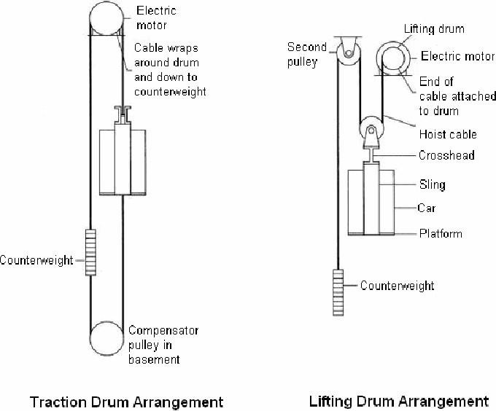

1. **hydraulictype**
   * Hydraulic elevators, on the other hand, are raised by forcing pressurized oil through a valve into a steel cylinder located above ground or underground.
   * The pressureforcesapistontorise,liftingtheelevatorplatformandcarenclosuremountedon it.
   * Thecaris loweredby openingthevalveandallowingtheweightofthecartoforceoilfromthe cylinder in a controlled manner. When the valve is closed the car is stopped.
   * Hydraulicelevatorsarecommonlyfoundinlow-risebuildingswithtwotofivefloors.

**Othertypesare:**

1. BedPassengerLift
2. Escalator
3. 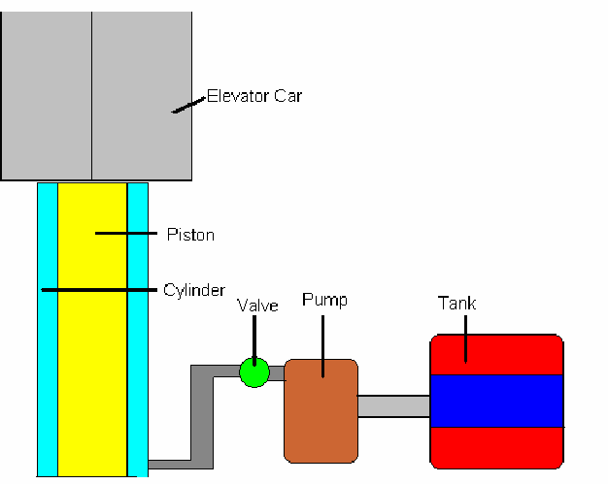FreightLift
4. LiftBank
5. PassengerConveyor
6. PassengerLift
7. ServiceLift
8. VehicleLift
   * 1. **Bed Passenger Lift**” means a lift usedfortransportationofpassengerandbed including stretcher.
     2. **Escalator**”meansaninclined,continuousstairwaywhichisdrivenbymechanicalpowerand used for raising or lowering passengers
     3. **FreightLift**”meansaliftmainlyintendedforthetransportofgoods,whicharegenerally accompanied by persons handling the goods.
     4. **LiftBank**”meansaliftsystemwithtwoormoreliftcarsservingazone
     5. **PassengerConveyor**”meansacontinuouswalkwaywhichisdrivenbymechanicalpowerand used for the conveyance of passengers on the same or between different traffic levels.
     6. **PassengerLift**”meansaliftwhichiswhollyormainlyusedtocarrypersons.
     7. **ServiceLift”**means alift,usedorintendedtobeusedexclusivelyforcarryinggoods,havinga ratedloadofnotmorethan250kgandacar inwhichtheareaofthefloorisnot morethan1m and whose height is not more than 1200 mm.
     8. “**VehicleLift**”meansaliftwhichissuitablydimensionedanddesignedforcarryingmotorvehicles

**Q.Usesofliftsandescalator.**

**ANS:**

**Usesofelevators**

1. Passenger Elevators are designed to move people between different floors of a building, their capacity being related to available floor space.
2. Passengerelevatorsmay bespecializedfortheservicethey perform,including:Hospitalemergency(Code blue), front and rear entrances, double Decker, and other uses.
3. Express elevators are designed to move people from ground floor to a sky lobby skipping several floors in between at a high speed.
4. Wheelchair, or platform lifts, a specialized type of elevator designed to move a [wheelchair](http://www.apexelevators.com/) 6 ft (1.8 m) or less, often can accommodate just one person in a wheelchair at a time with a maximum load of 1000 lb (455 kg).
5. [FreightElevators](http://www.apexelevators.com/)aremeanttocarryheavyloadsgenerally2300to4500kg.Theyusuallydon’tcomplywith fire service requirements and carrying passengers is generally prohibited unless specified.
6. On aircraft carriers, elevatorscarry aircraft between the flight deck andthe hangardeck for operations or repairs. These elevators are designed for much greater capacity than any other elevator.
7. A small freight elevator is often called a [dumbwaiter,](http://www.apexelevators.com/) often used for the moving of small items such as dishesina2-storykitchenorbooksinamulti-storyrackassembly.Passengersareneverpermitted on [dumbwaiters.](http://www.apexelevators.com/)
8. A specialtypeofelevatoristhepaternoster,aconstantlymovingchainofboxes,generallyusedin industrial plants.
9. Grain Elevatorsareusedtoelevategrainfor storageinlargevertical silos

**Forthesafeuseoflifts**

* + Maintainall the safetydevices operative
  + Don'toverloadlifts
  + Don'tinterfere withlift doors andequipment
  + Don'tusetheliftwhenthereisafire
  + Don'tjumpinsidelift
  + Children mustbe accompaniedbyadultswhen usinglifts
  + Stayclearofliftdoors,especiallywhentheliftdoorsareopeningorclosing

**Forthesafeuseofescalators**

* + Hold handrail andtopreventaccident, pleasedon'twalk onescalators
  + Holdchildren'shand
  + Don'tleanoverhandrail
  + Don'tplayorrunonescalators
  + Keepyourfeetawayfromtheskirtingoryellowstripes
  + KeepTrolleysstrollersandwheelchairsoffescalators
  + Don'tplaywithemergencystopbuttonwhichistobeusedonlywhenunderemergencysituation.

### Q.Describesoilandwastewaterinstallationsinhighrisebuildings Ans:

**Materials usedforwaste and dischargesystems**

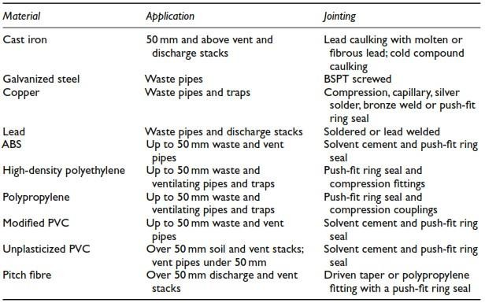

* **Maintenance**

Periodicinspection,testing,trapclearance,removalofrustandrepaintingshouldbeafeatureofanoverallservice

maintenanceschedule.Washersonaccesscoversrequire occasionalreplacement.Theuse of chemicaldescaling

agents, hand or machine operated rodding and high-pressure blockage removal must be carefully related to the drainage materials and the skill of the operator.



* **Limescaleremoval**

Limescaleisfoundinhard-waterareas.Adilutecorrosion-inhibitedacid-baseddescal-ingfluidisapplieddirectlyto

scale visible on sanitary appliances and is then thoroughly flushed with clean water. The fluid is a mixture of 15% inhibited hydrochloric acid and 20% orthophosphoric acid.

* **Removalofgreaseandsoapresidues**

Astrongsolutionof1kgofsodacrystalsand9lofhotwaterisflushedthroughthesystem.Thesodacrystalsare

mixed with the hot water in a basin. When the soda is fully dissolved, the plug is released. This may be necessary frequently in commercially used appliances.

* **Blockage**

Ahandplungermaybesufficientbutrepeatedblockageshouldbeinvestigated.Handroddingfromthenearest

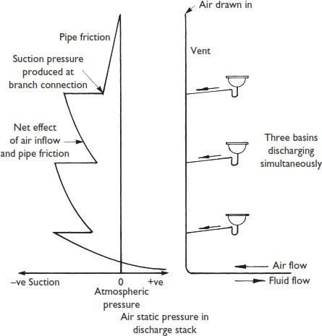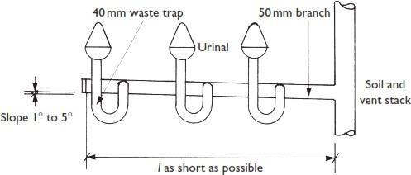access point can be performed using various tools as appropriate. A kinetic ram gun can be used for blockage in branch pipes. The impact of compressed air from the gun creates a shock wave in the water, which dislodges the solids. However, a blow-back from a stubborn blockage may injure the operator and damage the pipework and therefore the ram gun must be limited to the removal of soft materials.

**Branchforarangeofurinals**

**Soilandventstackinhousing.**

**Air staticpressuredistributioninsoilandventpipes.**

### Q.Electricaldistributionwithinabuilding:

1. Electricalservices–i)requirementsinhighrisebuildings
   1. Layoutofwiring-typesofwiring
   2. Fusesandtheirtypes
   3. Earthingandtheiruses

The safe and economical use of electricity is of paramount importance to the building user and the world as it is themosthighlyrefinedformofenergyavailable.Electricityproductionconsumesuptothreetimesitsownenergy value in fossil fuel, and electricity in its distributed form is potentially lethal.

Inthischapterthehandlingmethodsandsafetyprecautionsforutilizingelectricityareexplainedandarangeof calculations,whichcaneasilybeperformedbytheservicesdesignerorconstructorpriortoemployingspecialist help, is introduced.

### Electricaldistributionwithinabuilding:

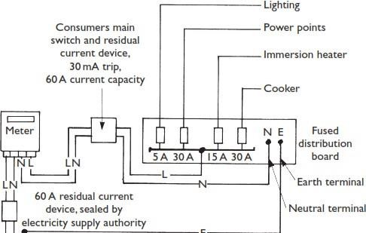The incoming cable, residual current device and meter are the property of the electricity supply authority. Underground cables are at a depth of 760 mm under roads, and enter the building through a large radius service ductof100mminternaldiameter.Adrainpipecanbeusedforthispurpose,laidthroughthefoundationsandrising directly to themeter compartment. External metercompartments can beused. Themeter should not beexposed to damp or hot conditions and the electricity supply authority’s advice should be sought. Figure 13.6 shows a distribution system for a dwelling.

## EARTHINGSYSTEMS

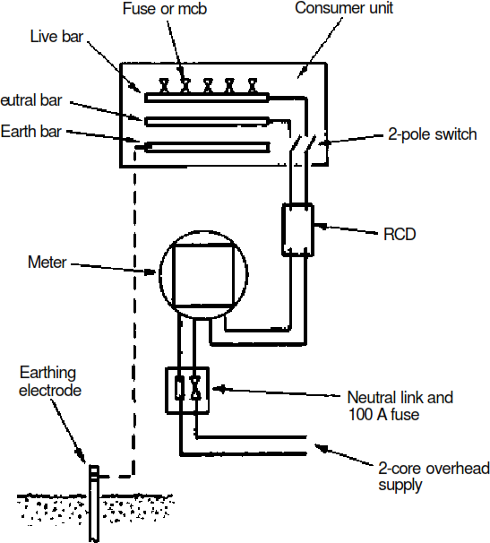

### ColdWaterDistributioninhighrisebuildinglayoutofinstallation

* **Direct Cold WaterSystems**~thecoldwater issuppliedtotheoutletsatmains pressuretheonly storagerequirementsisasmallcapacitycisterntofeedthehotwaterstoragetank.Thesesystems are suitable for districts which have high level reservoirs with a good supply and pressure. The main advantage is that drinking water is available from all cold water outlets
* For efficient operation, a high pressure water supply is essential particularly at periods of peak demand. Pipe work is minimal and the storage cistern supplying the hot water cylinder need only have115litrescapacity.Thecisternmaybelocatedwithintheairingcupboardorbecombinedwith thehotwatercylinder.Drinking water is available at every draw-off point and maintenance

valves should be fitted to isolate each section of pipe work. With every outlet supplied from the main,thepossibilityofbacksiphonagemustbeconsidered.Backsiphonagecanoccurwhenthere is a high demand on the main. Negative pressure can then draw water back into the main from a submerged inlet, e.g. a rubber tube attached to a tap or a shower fitting without a check valve facility left lying in dirty bath water.

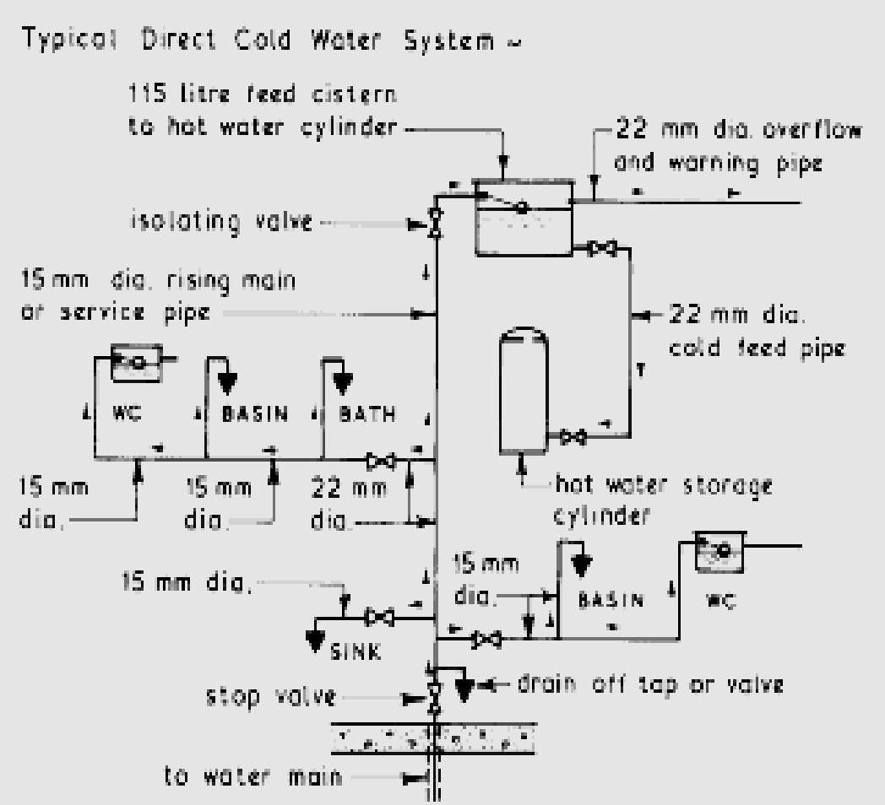

**HOTWATERSUPPLYSYSTEMS**

* + **DirectSystem ofHotWaterSupply**

The hotwaterfromtheboilermixesdirectlywiththewaterinthecylinder.Ifusedinasoft'waterareatheboilermust berustproofed.Thissystemisnotsuitedtohard'waters,typicalofthoseextractedfromboreholesintochalkorlimestonestrata. When heated the calcium precipitates to line the boiler and primary pipe work, eventually 'furring up' the system to render it ineffective and dangerous. The storage cylinder and associated pipe work should be well insulated to reduce energy losses. If a towel rail is fitted, this may be supplied from the primary flow and return pipes.

* + **IndirectSystemofHotWaterSupply**

This system is used in 'hard' water areas to prevent scaling or 'furring' of the boiler and primary pipe work. Unlike the direct system, water in the boiler and primary circuitisnotdrawnoffthroughthetaps.Thesamewatercirculatescontinuously

throughout the boiler, primary circuit and heat exchange coil inside the storage cylinder. Fresh water cannot gain access to the higher temperature areas where precipitation of calcium would occur. The system is also used in combination with central heating, with flow and return pipesto radiatorsconnected to the boiler. Boiler water temperature may be set by thermostat at about 80°C.

Asafetyvalveisnotnormallyrequiredonindirectopenventsystems,asintheunlikelyoccurrenceoftheprimaryflow and vent becoming obstructed, water expansion would be accommodated up the cold feed pipe.

**IndirectHotWater System foraHighRiseBuilding**

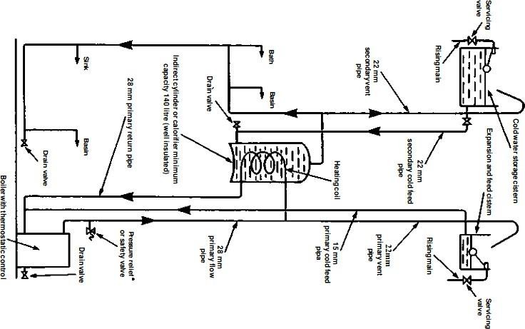

**VENTILATION**

**Ventilation**-ameansofchangingtheairinanenclosedspace:

Ventilationis**required to**

* Providefreshairforrespiration-approx.0.1to0.2l/sperperson
* Preservethecorrectlevelofoxygenintheair
* Control carbon dioxide content to no more than 0.1% concentrations above 2% are unacceptable as carbon dioxide is poisonous to humans and can be fatal.
* Controlmoisture -relativehumidity of30% to70%isacceptable.
* Remove excessheatfrommachinery,people,lighting,etc.
* Disposeofodours,smoke,dustandotheratmosphericcontaminants.
* Relievestagnationandprovideasenseoffreshness.

**Ventilationrates**

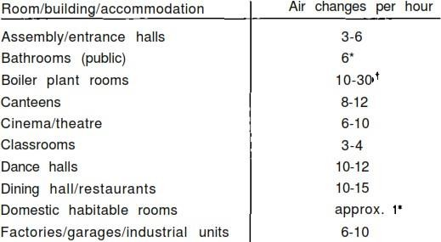

**TypesofVentilation**

1. **Natural ventilation**
2. **Artificial/Mechanicalventilation**
3. **Natural ventilation**

Ventilationprovidedbyvariousnaturalmeansiscallednaturalventilation.Naturalventilationisaneconomicmeansof providing air changes in a building.

Thesourcesfornaturalventilationare

* + windeffect/pressureand
  + Stackeffect/pressure.
  + PassiveStackVentilation(PSV)
  + **Stack effect**:

StackEffectisanapplicationofconvectedaircurrents.Coolairisencouragedtoenterabuildingatlowlevel.

Hereitiswarmedbytheoccupancy,lighting,machineryand/orpurposelylocatedheatemitters.Acolumnofwarm air rises within the building to discharge through vents at high level.

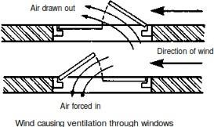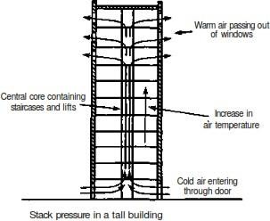

* **PassiveStackVentilation(PSV)**
  + PSV consists of vertical or near vertical ducts of 100 to 150 mm diameter, extending from grilles set at ceiling level to terminals above the ridge of a roof. Systems can be applied to kitchens, bathrooms,utility rooms and sometimes sanitary accommodation.
  + 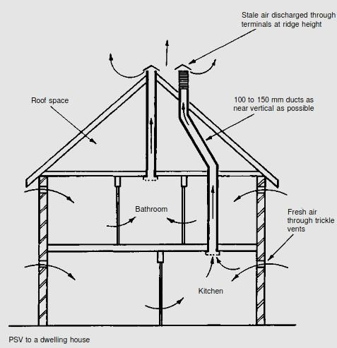PSV is energy efficient and environmentally friendly with no running costs. It works by combining stack effectwithairmovementandwindpassingovertheroof.Itisself-regulating,respondingtoatemperature differential when internal and external temperatures vary.

1. **Mechanicalventilation**

Mechanical ventilation systems are frequently applied to commercial buildings, workshops, factories, etc., where the air change requirements are defined for health and welfare provision.

1. MechanicallyAssistedVentilationSystems(MAVS)
2. MechanicalVentilationwithHeatRecovery(MVHR)
3. Fanassistedventilationsystems

* **MechanicallyAssistedVentilationSystems(MAVS)**
  + MAVS may be applied to dwellings and commercial premises where PSV is considered inadequate or impractical.
  + 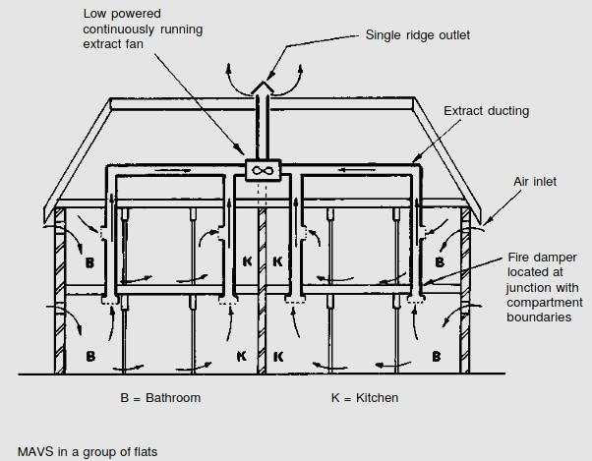This may be because the number of individual ducts would be excessive, i.e. too space consuming and obtrusive with several roof terminals.
* Alowpowered(40W)silentrunningfanisnormallylocatedwithintheroofstructure.Itrunscontinuously and may be boosted by manual control when the level of cooking or bathing activity increases.
* Humidity sensorscanalsobeusedtoautomaticallyincreaseairflow.
* **MechanicalVentilationwithHeatRecovery(MVHR)**
* MVHR is adevelopment of MAVS to include energyrecovery from the warmth in fan extractedmoistair from bathrooms and kitchens.
* Theheatrecoveryunitcontainsanextractfanforthestaleairandafreshairsupplyfanandaheatexchanger. This provides a balanced continuous ventilation system, obviating the need for ventilation openingssuchas trickle ventilators.
* Apartfromnaturalleakagethroughthebuildingandairmovementfrompeopleopeningandclosingexternal doors, the building is sealed to maximize energyeﬃciency. Upto 70% of the heatenergy in stale aircanbe recovered

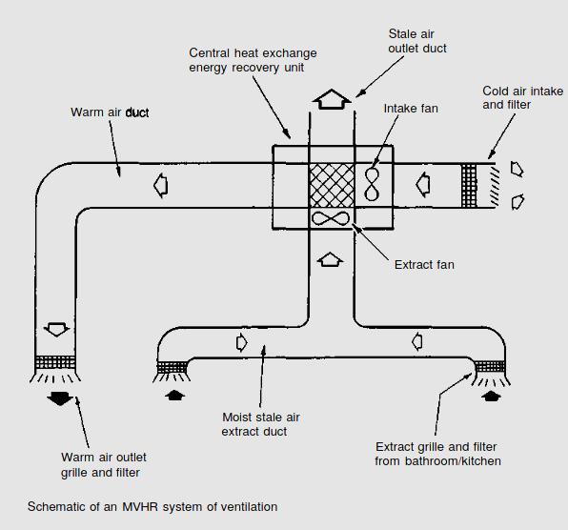

* **Fanassistedventilationsystems**
* Fanassistedventilation systemssupplyingexternal airtohabitable roomsmusthave afacilitytopre-heat the air.
* Theymustalsohavecontrolovertheamountofairextracted;otherwisetherewillbeexcessiveheatloss.

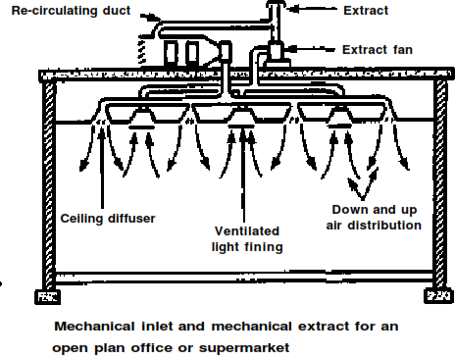

**TypesofFan**

* **Propellerfan-**doesnotcreatemuchairpressureandhaslimitedeffectinductwork.Idealforuseatair openings in windows and walls.
* **Axialflowfan**-candevelophighpressureandisusedformovingairthroughlongsectionsofductwork. The fan is integral with the run of ducting and does not require a base.
* **Bifurcatedaxialflowfan-**usedformovinghotgases,e.g.fluegases,andgreasyairfromcommercial cooker hoods.
* **Cross-flow ortangential fan**-usedinfanconvectorunits.
* **Centrifugal fan** - can produce high pressure and has the capacity for large volumes of air. Most suited to largerinstallationssuchas air conditioningsystems.Itmayhaveoneortwoinlets.Various formsofimpeller can be selected depending on the air condition. Variable impellers and pulley ratios from the detached drive motor make this the most versatile of fans.

### Lighting– Requirementof lighting,Measurement of lightintensity

Lighting or illumination is the deliberate application of [light](http://en.wikipedia.org/wiki/Light) to achieve some practical or visual effect. Lightingincludestheuseofbothartificial[lightsources](http://en.wikipedia.org/wiki/Light_source)suchaslampsandlightfixtures,aswellasnatural illumination by capturing [daylight.](http://en.wikipedia.org/wiki/Daylight)

Indoorlightingisusuallyaccomplishedusing[lightfixtures.](http://en.wikipedia.org/wiki/Light_fixture)

### Lightinghas thefollowingrequirements:

* Forvisibility
* Forcomfort
* Fordailyhabitablepurposes
* Forarefreshingenvironment
* Forgrowthoflifeandintelligence

**Typesoflighting/illumination:**

1. Naturalillumination
2. artificialillumination
3. **Natural illumination**

NaturalilluminationisprimarilyduetoSUNduringdaytime.So [Daylighting](http://en.wikipedia.org/wiki/Daylighting)isoftenusedasthemainsourceoflight during daytime in buildings.

* + Naturalilluminationbypenetrationofdirectsolaranddiffuseskyvisibleradiationrequirescorrectly designed passive architecture.
  + Largeglazedareasmayprovidesufficientdaylightingatsomedistanceintothebuilding,Using windows, skylights, or light shelves.
  + Reflectedilluminationfromotherbuildings,particularlyfromthosehavingreflectiveglazingormetallic architectural features, may cause annoyance.
  + Higherdaylightingcanalsocauseglare,overheatingandhighheatingandcoolingenergy costs.

1. **artificialillumination**

Artificiallightingisprovidedtosupplementdaylightonatemporaryorpermanentbasis.Artificiallightingisthe illumination by the help of light bulbs, lamps and several other electrical lighting systems.

* + Artificial[light sources](http://en.wikipedia.org/wiki/Light_source)such as lamps and light fixtures are necessary during dark areas of buildingsbothin day and night time.
  + Local control oflightsbymanual and/or automaticswitches aids economy in electricity consumption.

**Measurement oflightintensity**

**Illuminationintensity/illuminance:**

* Itisameasure oftheintensityoftheincident[light](http://en.wikipedia.org/wiki/Light)
* illuminance, measured in **lux** i.e. **lumen/m2 (*1 lux = 1 lumen /sqmeter)*** ameasureoftheintensity, as perceived by the human eye, of [light](http://en.wikipedia.org/wiki/Light) that hits or passes through a surface.
* Light Level or illuminance,is**thetotalluminousfluxincidentonasurface,perunitarea**.Theworkplane is where the most important tasks in the room or space are performed.
  + Theoutdoorlightlevelisapproximately10,000luxonaclearday.
  + Inthebuilding, intheareaclosesttowindows,thelightlevelmaybereducedto approximately 1,000 lux.
  + In the middleareaitsmaybeaslowas25-50lux.Additionallightingequipmentisoften necessary to compensate the low levels.
  + Earlieritwascommonwithlightlevelsintherange100-300luxfornormalactivities.
  + Forprecisionanddetailedworks,thelightlevelmayevenapproach1500-2000 lux.

Thetablebelowisguidanceforrecommendedlightlevelindifferentworkspaces

|  |  |  |
| --- | --- | --- |
| **Activity** | **Illumination(lux,lumen/m2)** |  |
|  | |
| Familylivingroom | 50lux | |
| Hallway/toiletinofficebuildings | 80lux | |
| Homes,Theaters,Archives | 150 | |
| EasyOfficeWork,Classes | 250-300 | |
| ShowRooms,Laboratories | 500 | |
| DetailedDrawingWork,VeryDetailedMechanicalWorks | 1500-2000 | |

**QUESTIONSANDANSWERS**

1. **writefourpropertiesoffreshconcrete**
   1. [Setting](http://www.aboutcivil.com/Properties-of-concrete-factors-affecting-them.html#se)
   2. [Workability](http://www.aboutcivil.com/Properties-of-concrete-factors-affecting-them.html#wo)
   3. [BleedingandSegregation](http://www.aboutcivil.com/Properties-of-concrete-factors-affecting-them.html#bl)
   4. [Hydration](http://www.aboutcivil.com/Properties-of-concrete-factors-affecting-them.html#hy)
2. **writefourpropertiesofhardenedconcrete**
   1. Strength
   2. Durability
   3. Creep
   4. Shrinkage
   5. Elasticity
   6. Permeability
3. **Whatisanescalator?**

**Escalator** is a moving staircase – a [conveyor transport](http://en.wikipedia.org/wiki/Conveyor_transport_(disambiguation)) device for carrying people between floors of a building

1. **Defineplinthband**

***PlinthBand***

Plinth band is a band provided at plinth level of walls on top of the foundation wall. This is to be provided where strip footings of masonry are used and the soil is either soft or uneven in its properties as frequently happens in hill tracts.

1. **Whatisadragline?**

Itisanexcavatingequipment,usedtoexcavateearthandloadingearthintohaulingunits,alsodeposit the excavated earth in embankments or spoil banks.

1. **DefineOwningandoperatingcost**

Thecostofownershipofequipmenttowhichthefuelcostisaddedforrunningtheequipment

1. **Whatiscuringofconcrete?**

Curingistheprocessof controlling the rate and extentof moisture loss from concreteduring cement hydration

1. **WriteratiosforM15,M20.**

M15-1:2:4,M20–1:1½:3

1. **Writetwomethodsofcuring.**
   1. Ponding
   2. Wetcovering
2. **Writeanddefinetheunitofillumination.**

lux i.e. lumen/m2 is unit to measure illumination and is defined as is the total luminous flux incident ona surface, per unit area

1. **Defineworkabilityofconcrete.**

*Workability*istheabilityofafreshconcretemixwithwhichtheconcretecanmix, transport, place and compacted is called the workability of concrete

1. **Definecreepofconcrete.**

**Creep**isthe tendency of concrete structures to move slowly or deform permanently under the influence of [stresses.](http://en.wikipedia.org/wiki/Stress_(physics))

1. **WhataretheFactorsaffectingworkability**
   1. Watercontentintheconcretemix
   2. Amountofcement&itsProperties
   3. AggregateGrading(Size Distribution)
   4. NatureofAggregateParticles (Shape,SurfaceTexture,Porosity etc.)
2. **HowToimprovetheworkabilityofconcrete**
   1. increasewater/cementratio
   2. increasesizeofaggregate
   3. increasethemixingtime
   4. with additionof air-entraining mixture
3. **WritefourMethodsofproportioningconcretemix.**
   1. ACIMixdesignmethod
   2. DOEMixdesignmethod
   3. RLLMixdesignmethod
   4. Minimumvoidmethod
4. **Whatareplanconfigurationproblems**
   1. symmetry
   2. Regularity
   3. SeparationofBlocks
   4. simplicity
5. **WhatisRetrofittingofStructures?**

Retrofittingisthemodificationofexisting[structures](http://en.wikipedia.org/wiki/Built_environment)tomakethemmoreresistantto[seismicactivity](http://en.wikipedia.org/wiki/Seismology),ground motion, or [soil](http://en.wikipedia.org/wiki/Soil) failure due to [earthquakes.](http://en.wikipedia.org/wiki/Earthquake)

1. **Whatarethecompactingequipments?**
   1. tampingrollers
   2. Smoothwheelrollers,
   3. Pneumatictiredrollersand
   4. vibratingcompactors
2. **Whataretheearthmovingequipments**
   1. dragline,
   2. tractor,
   3. bulldozer,
   4. Powershovel
3. **Whatisbatchingofconcrete?**

**Ans:**Batchingistheprocessofweighingorvolumetricallymeasuringeachingredients(cement,sand

, coarseaggregate, water and admixture) and placing the ingredients into a mixer for a batch of concrete to produce a uniform quality concrete mix.

1. **Writethetypesofdrumtypemixers.**

**Ans:**1.Tilting 2.Non-Tilting 3.ReversingorForcedAction

1. **Whatishydrationofcement?**

Ans:Thereactionofcementwithwateristermed"hydration".Thisinvolvesmanydifferentreactions,often occurring at the same time. As the reactions proceed, the products of the hydration process gradually bondtogether the individualsandand gravel particles,andother components,toform a solid mass.

1. **Writetwomethodsofmeasuringworkabilityofconcrete.**

Ans:Slumpconetest,Compactingfactortest

1. **Definesegregationandbleedingofconcrete.**

**Segregation**canbedefinedastheseparationoftheconstituentmaterialsofconcrete

**Bleeding** in concrete is sometimes referred as water gain. It is a particular form of segregation, in which some of the water from the concrete comes out to the surface of the concrete

1. **defineW/Cratioofconcrete**

The**water–cement ratio** is theratiooftheweightofwatertotheweightof [cement](http://en.wikipedia.org/wiki/Cement)usedina [concrete](http://en.wikipedia.org/wiki/Concrete)mix and has an important influence on the quality of concrete produced. A lower water-cement ratio leads to higher strength and durability

1. **Whatarethetypesofelevator?**
   1. electrictractiontype
   2. hydraulic type
2. **WhatisStackeffect?**

* Stack effect is the phenomenon in a building or building component caused by wind pressure and temperature differentials which results in air being drawn through some components of a building and out others creating a continuous pattern of air flow.
* Duringtheheatingseason,thewarmerindoorairrisesupthroughthebuildingandescapes at the top either through open windows, ventilation openings, or other forms of leakage. The rising warm air reduces the pressure in the base of the building, drawing coldairin through either open doors, windows, or other openings and leakage. During thecooling season, the stack effect is reversed

1. **WhatareCeilingBandandGableBand?**

***CeilingBand***

Itisabandprovidedimmediatelybelowtherooforfloors.

***GableBand***

Itisabandprovidedatthetopofgablemasonrybelowthepurlins.

1. **Whatisearthquake?**

Anearthquakeisthevibrationoftheearth’ssurfacethatfollowsasuddenreleaseof energy in the crust. During an earthquake, the ground surface moves in all directions

1. **WhyVentilationisrequired?**
   1. Providefreshairforrespiration
   2. Preservethecorrectlevelofoxygenintheair
   3. Controlcarbondioxidecontenttonomorethan0.1%
   4. Control moisture
2. **Whatarethetypesofhotwatersupplysystems**
   1. **DirectSystemofHotWaterSupply**
   2. **indirectSystemofHotWaterSupply**
3. **WhatiscuringrequirementsofConcrete**

Curing is necessary to provide continuously wetting the exposed surface thereby preventing the loss of moisturefromit.Pondingorsprayingthesurfacewithwateraremethodstypicallyemployedtothis end.

1. **Whatisdesignmixconcrete?**

It is a process of selecting suitable ingredients and determining their relative proportions with the objective of producing concrete of having certain minimum workability, strength and durability as economically as possible.

1. **Whatarethedatarequiredformixdesign?**
   1. Characteristiccompressivestrength
   2. Degreeofworkability
   3. Typeandmaximumsizeofaggregatetobeusedand
   4. Standarddeviation(s)ofcompressivestrengthofconcrete.
2. **definebulldozer**

Itisanexcavatingequipmentforshorthaulapplicationsupto100m,andisaversatileequipment.

1. **Whatarethefactorsaffectingowningandoperatingcostofequipment?**
   1. initial cost
   2. servicecondition
   3. no.ofhoursitistobeusedperyear
   4. Usefullifeetc.
2. **Whatarethecostsincludedinowningandoperating?**
   1. depreciationcost
   2. maintenanceand repair cost
   3. investmentcost
   4. fuelcost
   5. lubricatingoil cost
3. **Whataretheadvantagesofmixdesign?**
   1. Betterstrength
   2. Betterimperviousnessanddurability
   3. Denseandhomogeneousconcrete
   4. Economical
4. **WhataretheRequirementsofLighting?**
   1. Forvisibility
   2. Forcomfort
   3. Fordailyhabitablepurposes
   4. Forarefreshingenvironment
   5. Forgrowthoflifeandintelligence
5. **WhatarethesystemsofMechanicalventilation?**
   1. MechanicallyAssistedVentilationSystems(MAVS)
   2. Mechanical Ventilation with Heat Recovery (MVHR)
   3. Fanassistedventilationsystems

## PREFABRICATION

* Prefabrication is the practice of assembling components of a structure in a factory or other manufacturing site, and transporting complete assemblies or subassemblies to the construction site where the structure is to be located.
* Prefabrication isone of thearchitectural constructions. Large units of a building are produced in factories to be assembled, ready-made, on the building site.
* This technique permits the speedy erection of very large structures. Units may include doors, stairs, windows, wall panels, floor panels, roof trusses and even entire buildings. Prefabricated building:
* Prefabricated building is a type of building that consists of several factory-built components or units that are assembled on-site to complete the unit. The term 'prefabricated' is buildings built in components (e.g. panels), modules (modular homes), transportable sections (manufactured homes),It may also be used to refer to mobile homes.
* DifferentBetweenPrefabricatedConstructionsandConventionalType:Theconventionalmethod of building a house is to transport bricks, timber, cement, sand, and construction aggregate, etc to the site, and to construct the house on site from these materials.
* In prefabricated construction, only the foundations and floor slabs are constructed in this way, while sections of walls and roof are prefabricated

### NeedforPrefabrication:

1. Costofconstruction
2. shorterconstructiontimeϖeasyofexpansion
3. utilizationofmaterial
4. attractivefinishes
5. highlyefficientfor weatherresistance
6. singlesourceassurance
7. insuranceadvantage
8. MaterialPropertiesInofPrefabricatedStructuresQuicktoassembleϖCost-effective
9. Portable/movable
10. Strong
11. Waterproof,Moistureproof
12. FireResistant

### PrefabricationTypes:

1. Conventional prefabrication construction is the most traditional construction method where all the construction activities are in-situ practices on site:
2. Semi-prefabrication divides as two sub-categories: system formwork and nonstructural semi- prefabrication,involvingapartofin-situconstructionactivitiesandapartofprefabrication.Normally, the non-structural semi-prefabrication is applied on façade, curtain walls, lost form systems and dry wall systems;
3. Comprehensive prefabrication involves a structural part and pre-finished construction. Examples of applicationsofstructuralcomprehensiveprefabricationincludestaircases,slabs,columnsandbeams: and
4. Volumetric off-site fabrication encloses usable space but does not constitute the whole building. Volumetric off-site fabrication is mainly used for ‘facilities’ and includes solutions on office washrooms, plant rooms, building services risers and lifts.

## ADVANTAGESOFPREFABRICATION

1. Self-supporting ready-made components are used, so the need for formwork, shuttering and scaffolding is greatly reduced.
2. Construction time is reduced and buildings are completed sooner, allowing an earlier return of the capital invested.
3. Qualitycontrolcanbeeasierinafactoryassemblylinesettingthanaconstructionsitesetting.
4. Prefabrication can belocatedwhereskilledlabourismorereadilyavailableandcostsoflabour,power, materials, space and overheads are lower.
5. Timespentinbadweatherorhazardousenvironmentsattheconstructionsiteisminimized.
6. Less waste may be generated and in a factory setting it may be easier to recycle it back into the manufacturing process, for instance it is less costly to recycle scrap metal generated in a metal fabrication shop than on the construction site.
7. On-siteconstructionandcongestionis minimized.

## DISADVANTAGESOFPREFABRICATION

1. Careful handling of prefabricated components such as concrete panels or steel and glass panels is required.
2. Attention has to be paid to the strength and corrosion-resistance of the joining of prefabricated sections to avoid failure of the joint.
3. Similarly,leakscanformat jointsin prefabricatedcomponents.
4. Transportation costs may be higher for voluminous prefabricated sections than for the materials of which they are made, which can often be packed more compactly.
5. Large prefabricated sections require heavy-duty cranes and precision measurement and handling to place in position.

# Modularcoordination:

Modular coordination or MC is a dimensional system. It is a dimension and space coordination concept inwhichbuildingandcomponentsareplacedattheirdesignationsbasedontheunitorbasicmodule knownas"1M"thatequalsto100mm.TheuseofMCisanimportantfactorinIBSeffectiveapplication as it completes the industry through quality control and increase of productivity.

QUESTIONSANDANSWERS

1. Defineprefabrication.

The term prefab can apply to any construction method where the significant part oftheconstructiontakesplaceoffsiteinafactory.Thatproducesrelativelylargecomplex features that assembled at the site into the finished building .

1. WhatismeantbymodularCoordination?

Modular coordination is a concept for coordinating dimension and space for which buildingandcomponentaredimensionallyitusedandpositionedinbasicunits(or)modules.

The standard specify that the module basic M = 100 mm .Asthebasicunitbeusedina square of M .

1. WhatarethecharacteristicsofModularconcept.
2. The basic module is small in terms of add size in order to provide design flexibility, yet large enough to promote simplification in the component variation in sizes .
3. Industryfriendly features that not only for manufacturing but also the transportation andassembly requirements .
4. Internationallyacceptedtosupportinternationalmarket.
5. Writeouttheadvantages&disadvantagesofprefabrication?
6. Self supporting readymade components are used ,so the need for formwork , shutteringand scaffolding is greatly reduced .
7. On-siteconstructionandconditionisminimized.
8. Lesswastemayoccur.

# Disadvantages:

1. Carefulhandlingofprefabricatedcomponentssuchasconcretepanels(or)steeland glass Panels is reduced .
2. Similarlyleakscanformatjointsisprefabricatedcomponent.
3. DefinethetermOff-sitefabrication.

Off-sitefabricationistheprocessthatincorporatesprefabricationandpreassemble

the process involvesthedesignandmanufactureofunitsusuallyremotefromtheworksiteand the installation at the site to form the permanent work at the site.

1. WriteshortnoteonProductionprocess.

TheproductionofconcreteblocksconsistsoffourbasicprocessTheyare,

* 1. Mixing2)Moulding3)Curing4) Cubing

1. Listoutthelimitationsofprefabrication.
2. Extrareinforcementisrequiredtotakecareofhandlinganderectionstresses.
3. Tempraraypropsmayberequiredinsomecases,beforetheun-siteconcretejoints achieve strength .
4. Thecracksmaydevelopatthejointsbetweentheprecartin–siteconcretedueto shrinkage andtemperature stresses.Toovercomethem extrasteelisrequired acrossjoint.
5. WhatareallthePrefabmaterials?

* Structuralinsulatedpanels(SIPs).
* Insulatingconcreteforms(ICFS).
* Prefabfoundationsystem.
* Steelframing .
* Concreteframing .
* Large-modularsystem

1. Insulatingconcreteforms:

Insulating concrete forms (ICE) are a prefab construction material consisting of hollow EPS foam blocks that are stacked and glued together on-site , creating the form that is filled with reinforcing bars and concrete.

1. WriteshortnoteonPrinciplesofMCConcept?

TheprincipleobjectiveofimplantingMCistoimproveproductivitythroughthereduction of wastages in the production ,installation process , to improve quality in the construction industry and to encourage an open system .

PART B

# ExplainModularCoordinationindetail

Modular coordination means the interdependent arrangement of a dimension based on aprimaryvalueacceptedasamodule.Thestrictobservanceofrulesofmodularcoordination facilitated,

1. Assemblyofsinglecomponentsintolargecomponents.
2. Fewestpossibledifferenttypesofcomponent.
3. Minimumwastageofcuttingneeded.

**Modularcoordination**isthebasisforastandardizationofamassproductionofComponent. A set of rules would be adequate for meeting the requirements of conventional and prefabricated construction. These rules are adaptable for,

* 1. Theplanninggridinbothdirectionsofthehorizontalplanshallbe
     1. 3Mforresidentialandinstitutionalbuildings,
     2. Forindustrialbuildings, 15M for spans up to 12m

30Mforspansbetween12mand18m 60M for spans over 18m

Thecentrelinesofloadbearingwallsshallcoincidewiththe gridlines

* 1. In case of external walls the grid lines shall coincide with the centre line of thewalloraline on the wall 5 cm from the internal face of the wall
  2. Theplanningmoduleintheverticaldirectionshallbe1Muptoandincluding ahtof 2.8M.
  3. Preferredincrementsfoathestillheights,doors,windowsandotherfenestrationshallbe 1M.
  4. In case of internal columns the grid lines shall coincide with the centre lines of columns. In case of external columns, the gridlinesshall coincidewith the centre linesof the columns in thestoreyoralineinthecolumnfromtheinternalfaceofthecolumninthetopmoststorey.

**CONSTRUCTIONEQUIPMENTS**



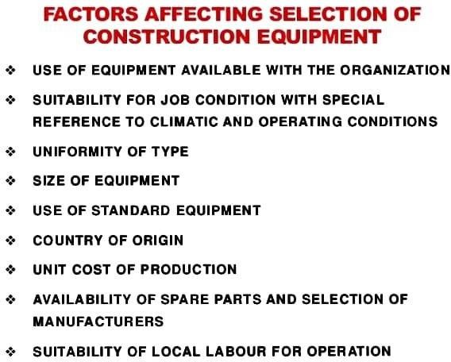

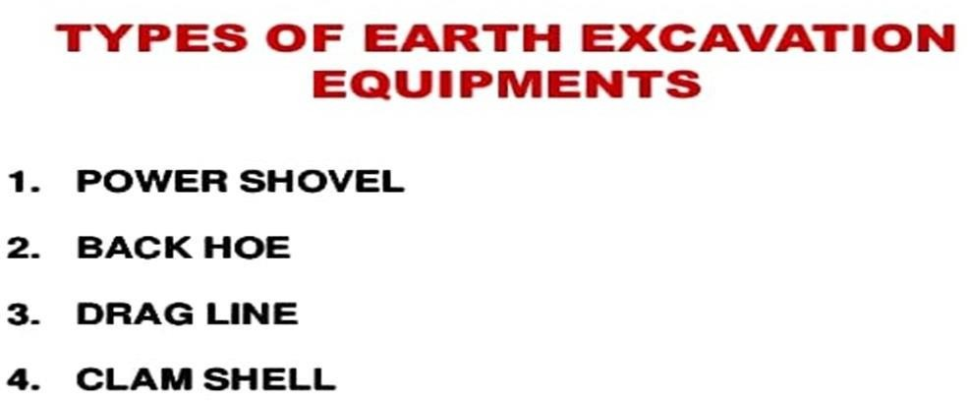

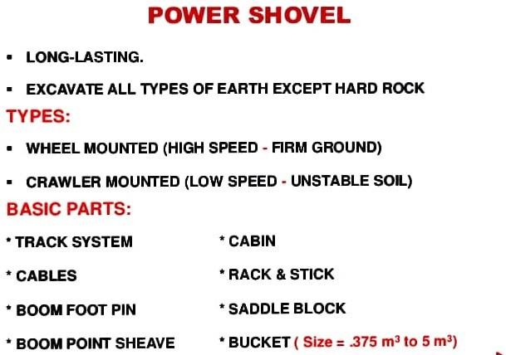

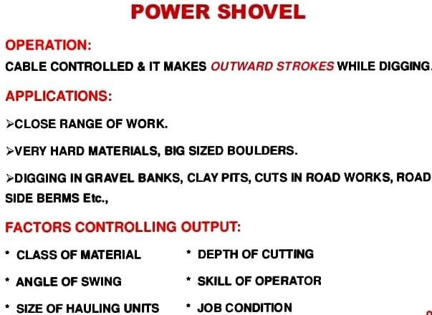

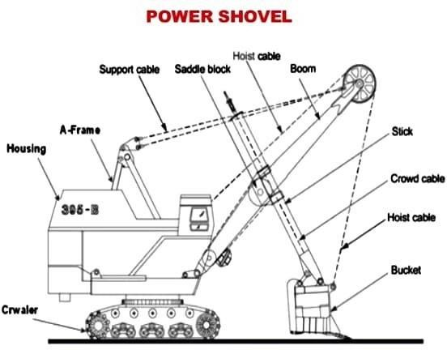

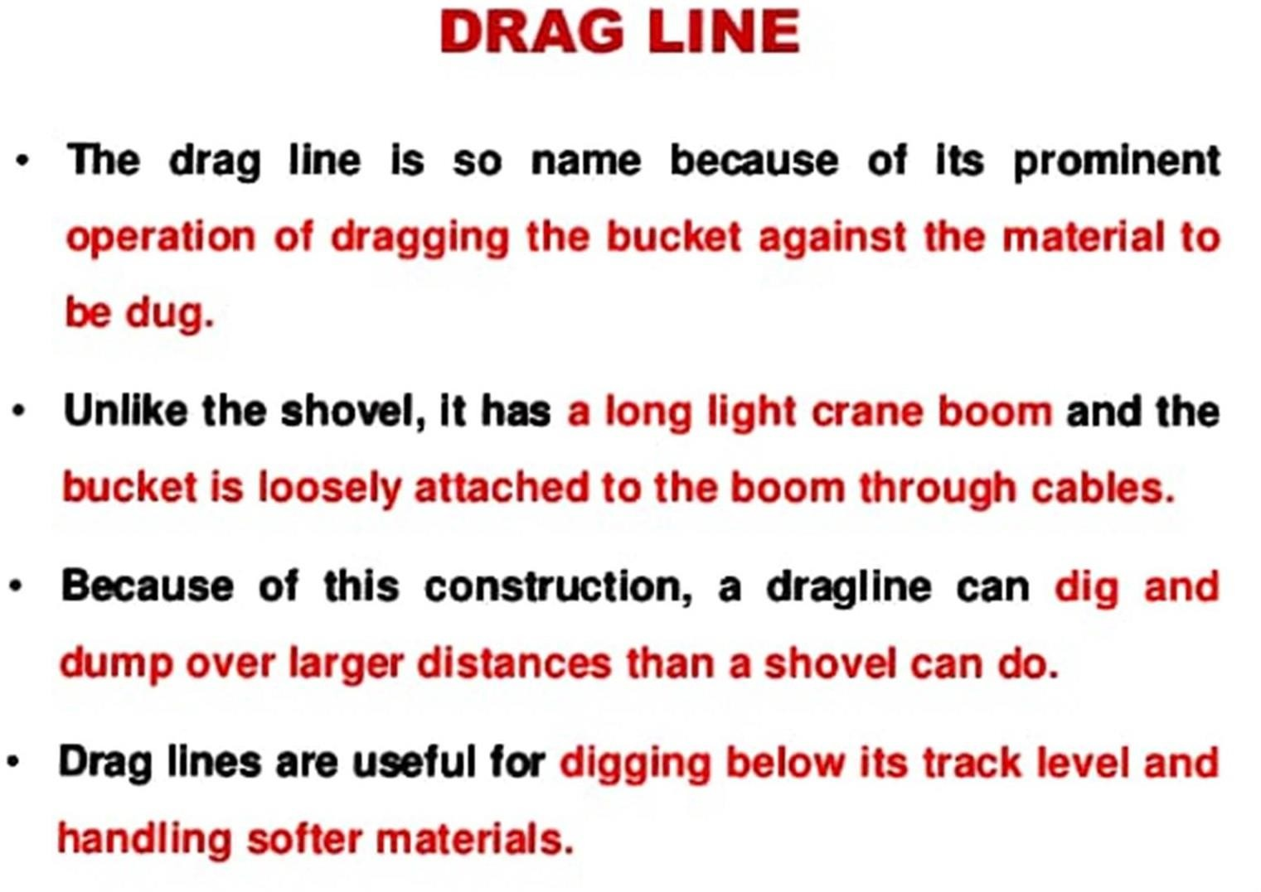

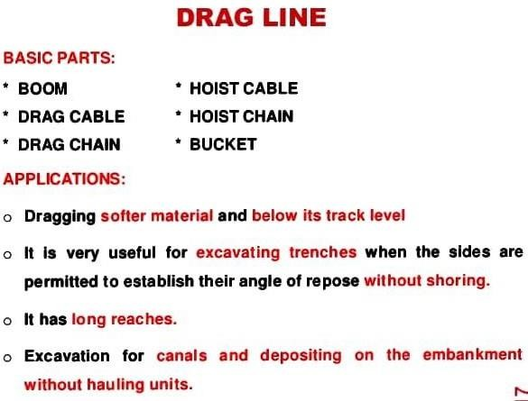

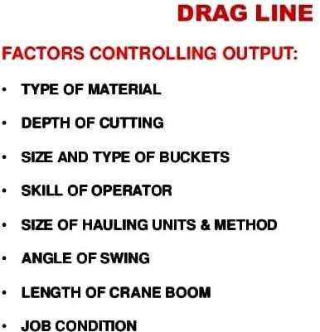

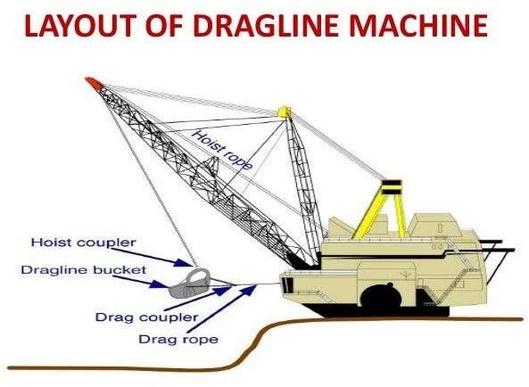

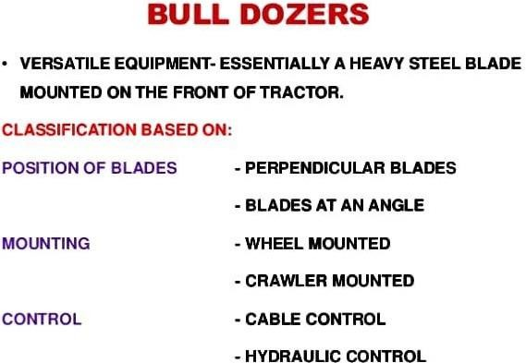

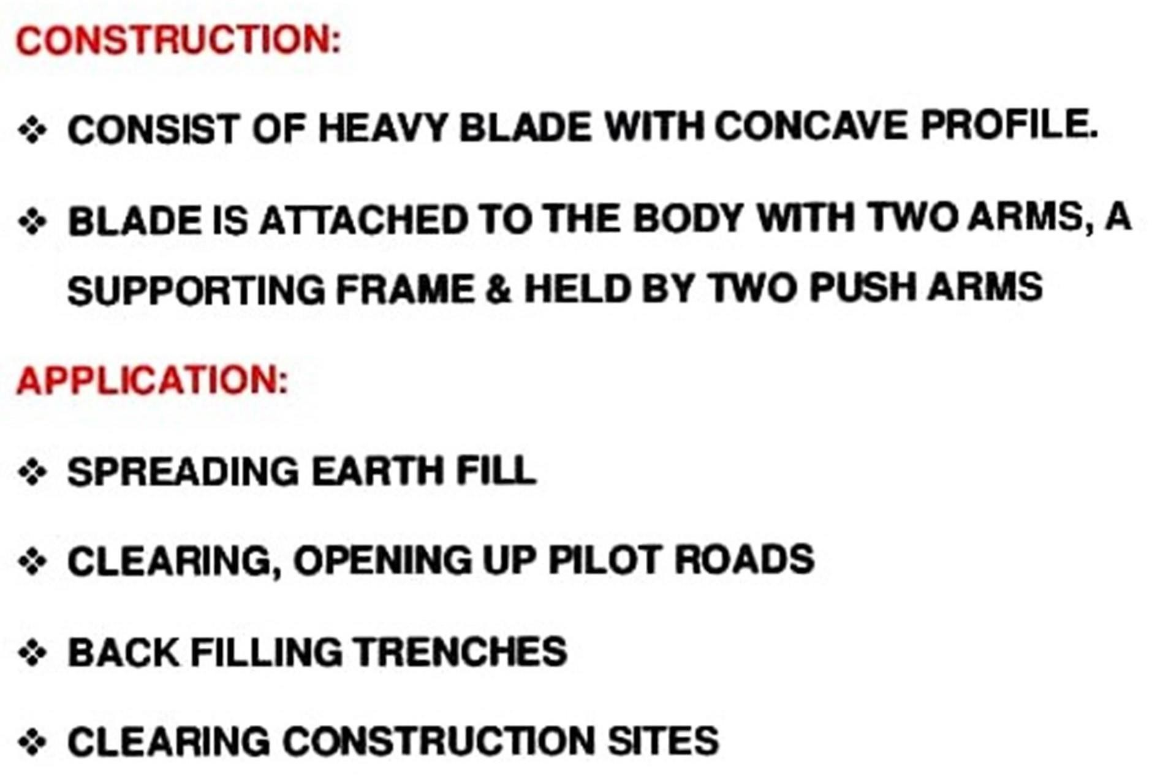

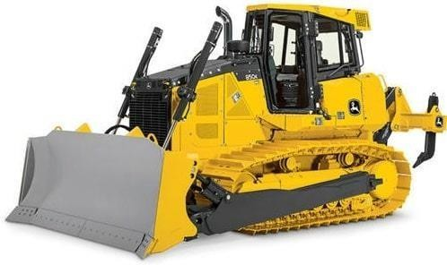

**Typesofbulldozerblade**

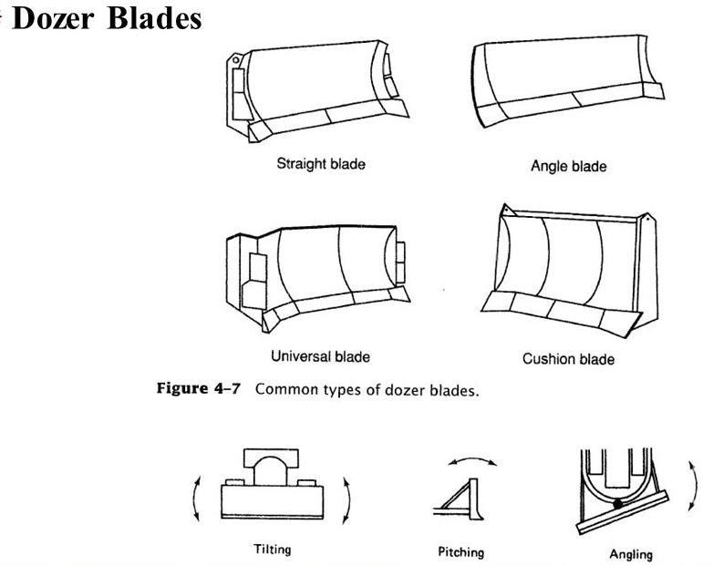

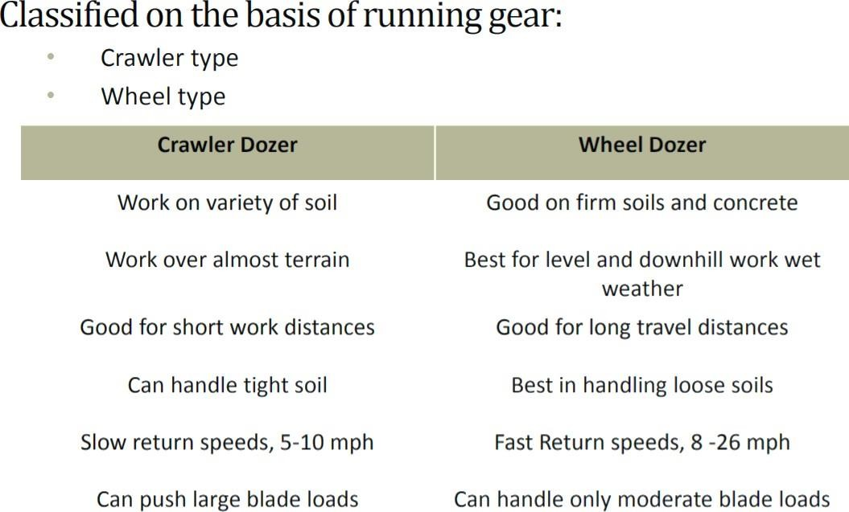

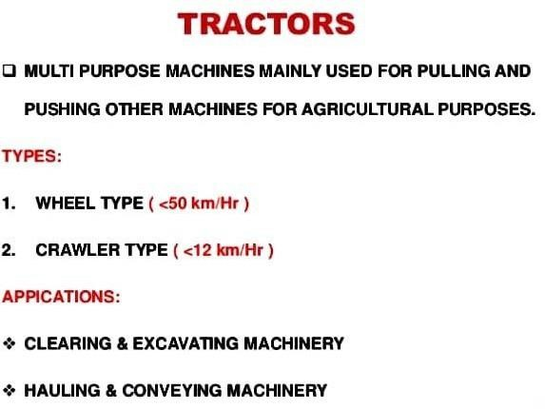

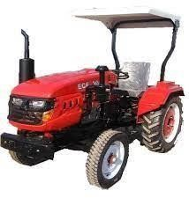

**WHEELTRACTOR**





